LAB EXPERIMENTS 1 TO 20

Course: Machine Learning
Course Code: ITA0610

Department of Electronics and Communication Engineering
Saveetha School of Engineering
Saveetha Institute of Medical and Technical Sciences

Chennai

Submitted By:
Saravana Yogesh M
Register Number: 192412273

EXPERIMENT 1:
Implement and demonstrate the FIND-S algorithm for finding the most specific hypothesis
based on a given set of training data samples.

1. Aim
To implement and demonstrate the FIND-S algorithm to find the most specific hypothesis that is consistent with a given set of positive training data samples.

2. Procedure
- Initialize the hypothesis with the most specific hypothesis.
- Read the training dataset containing attributes and a target/class label.
- Consider only the positive training examples.
- Compare each positive example with the current hypothesis.
- If an attribute value in the hypothesis differs from the positive example, replace it with ? (any value).
- Ignore negative examples.
- Continue until all training examples are processed.
- Display the final hypothesis, which represents the most specific hypothesis consistent with all positive examples.

3. Coding – Python
# FIND-S Algorithm

# Training dataset
training_data = [
['Sunny', 'Warm', 'Normal', 'Strong', 'Warm', 'Same', 'Yes'],
['Sunny', 'Warm', 'High', 'Strong', 'Warm', 'Same', 'Yes'],
['Rainy', 'Cold', 'High', 'Strong', 'Warm', 'Change', 'No'],
['Sunny', 'Warm', 'High', 'Strong', 'Cool', 'Change', 'Yes']
]

# Attribute names
attributes = [
'Sky', 'Temperature', 'Humidity',
'Wind', 'Water', 'Forecast'
]

# Initialize hypothesis with most specific values
hypothesis = ['0'] * len(attributes)

print("Initial Hypothesis:", hypothesis)

# FIND-S algorithm
for row in training_data:

# Check whether example is positive
if row[-1] == 'Yes':

for i in range(len(attributes)):

# First positive example
if hypothesis[i] == '0':
hypothesis[i] = row[i]

# If values are different, generalize
elif hypothesis[i] != row[i]:
hypothesis[i] = '?'

print("Updated Hypothesis:", hypothesis)

# Display final hypothesis
print("\nFinal Most Specific Hypothesis:")
print(hypothesis)

OUTPUT:
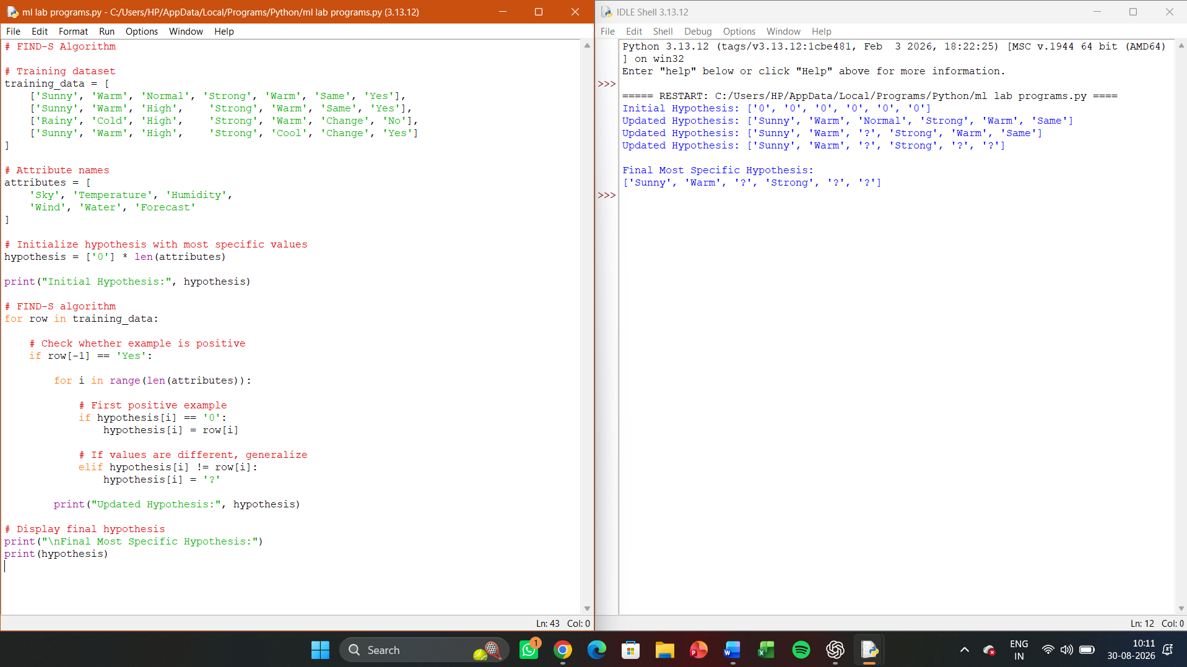

RESULT
The FIND-S algorithm successfully finds the most specific hypothesis from the given positive training samples.

EXPERIMENT 2:

1. Aim
To implement and demonstrate the Candidate-Elimination algorithm in Python using training data stored in a CSV file, and to obtain the set of all hypotheses consistent with the given training examples by finding the Specific Boundary (S) and General Boundary (G).

2. Procedure
- Create a CSV file containing the training examples and their target class.
- Read the CSV dataset using Python's pandas library.
- Initialize:
  - S with the most specific hypothesis.
  - G with the most general hypothesis.
- Read each training example one by one.
- For a positive example:
  - Generalize S wherever necessary.
  - Remove hypotheses from G that do not cover the positive example.
- For a negative example:
  - Specialize G to exclude the negative example.
  - Remove hypotheses from S that cover the negative example.
- Remove redundant hypotheses from the boundaries.

3. Python Coding
import pandas as pd
# Read training data from CSV file
data = pd.read_csv("training_data.csv")
print("Training Data:")
print(data)

# Separate attributes and target
attributes = list(data.columns[:-1])
target = data.columns[-1]

# Number of attributes
n = len(attributes)

# Most specific hypothesis
S = ['Ø'] * n

# Most general hypothesis
G = [['?'] * n]
def covers(hypothesis, example):

for h, x in zip(hypothesis, example):

if h == 'Ø':
return False

if h != '?' and h != x:
return False

return True
def generalize_S(S, example):

new_S = S.copy()

for i in range(n):

if new_S[i] == 'Ø':
new_S[i] = example[i]

elif new_S[i] != example[i]:
new_S[i] = '?'

return new_S
def specialize_G(G, example, S):

new_G = []

for g in G:

if covers(g, example):

for i in range(n):

if g[i] == '?':

# Create a specialized hypothesis
if S[i] != '?' and S[i] != 'Ø':
new_g = g.copy()
new_g[i] = S[i]
new_G.append(new_g)

else:
new_G.append(g)

return new_G

for index, row in data.iterrows():

example = row.iloc[:-1].tolist()
label = row.iloc[-1]

# Positive example
if label == "Yes":

# Generalize S
S = generalize_S(S, example)

# Remove G hypotheses that don't cover positive example
G = [g for g in G if covers(g, example)]

# Negative example
else:

# Remove S if it covers negative example
if covers(S, example):
S = ['Ø'] * n

# Specialize G
G = specialize_G(G, example, S)

print("\nExample:", example)
print("Class:", label)
print("S Boundary:", S)
print("G Boundary:", G)
print("\nSpecific Boundary (S):")
print(S)

print("\nGeneral Boundary (G):")
for g in G:
print(g)

RESULT
The Candidate-Elimination algorithm was successfully implemented in Python using a CSV training dataset.

OUTPUT
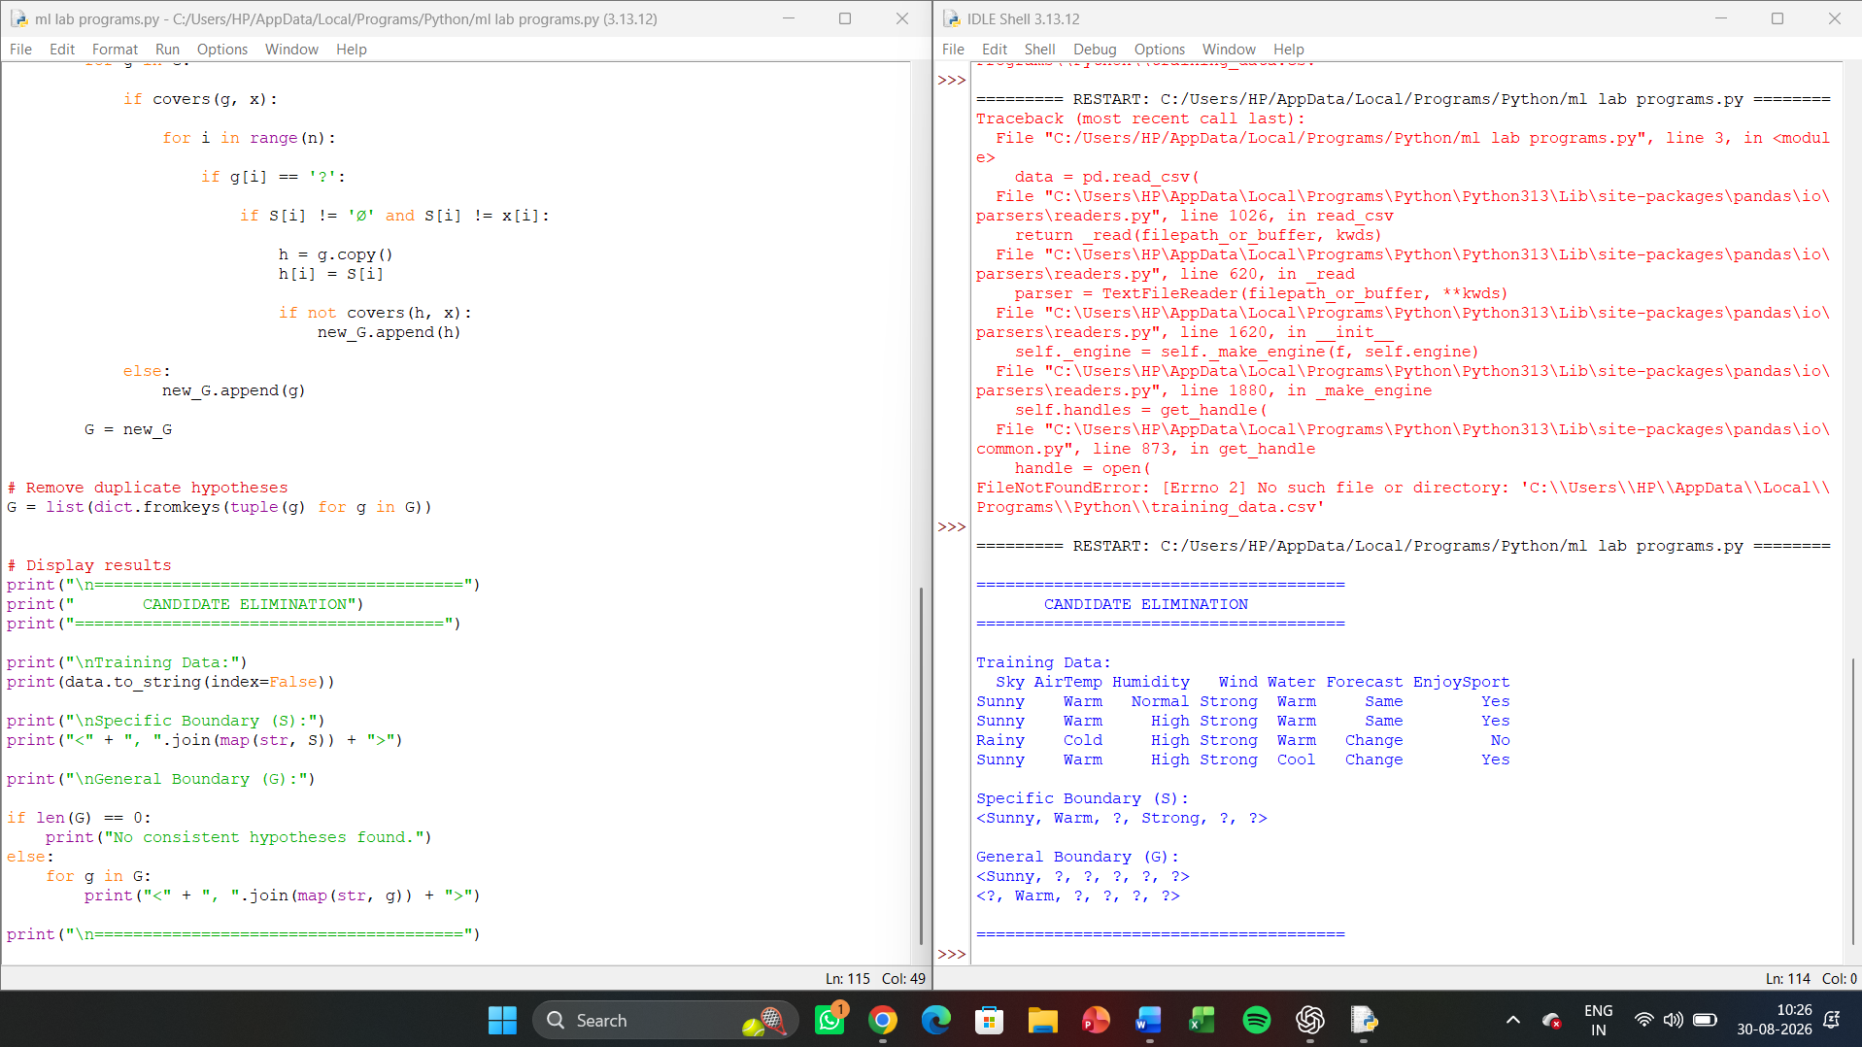
EXPERIMENT 3:
Demonstrate the working of the decision tree based ID3 algorithm. Use an appropriate data set
for building the decision tree and apply this knowledge to classify a new sample.

1. Aim
To implement and demonstrate the ID3 (Iterative Dichotomiser 3) decision tree algorithm using a suitable training dataset, construct a decision tree based on Information Gain, and use the generated tree to classify a new sample.

2. Procedure
- Create a training dataset containing several attributes and a target class.
- Calculate the entropy of the target attribute.
- Calculate the Information Gain for each input attribute.
- Select the attribute with the highest Information Gain as the root node.
- Divide the dataset according to the values of the selected attribute.
- Repeat the entropy and Information Gain calculations for each subset.
- Continue recursively until the data is classified or no attributes remain.
- Construct the final decision tree.
- Provide a new sample to the decision tree.
- Traverse the tree according to the sample's attribute values and determine its predicted class.

CODING
import pandas as pd
import math

# ID3 Decision Tree Algorithm

# Dataset
data = pd.DataFrame({
'Outlook': [
'Sunny', 'Sunny', 'Overcast', 'Rain', 'Rain',
'Rain', 'Overcast', 'Sunny', 'Sunny', 'Rain',
'Sunny', 'Overcast', 'Overcast', 'Rain'
],
'Temperature': [
'Hot', 'Hot', 'Hot', 'Mild', 'Cool',
'Cool', 'Cool', 'Mild', 'Cool', 'Mild',
'Mild', 'Mild', 'Hot', 'Mild'
],
'Humidity': [
'High', 'High', 'High', 'High', 'Normal',
'Normal', 'Normal', 'High', 'Normal', 'Normal',
'Normal', 'High', 'Normal', 'High'
],
'Wind': [
'Weak', 'Strong', 'Weak', 'Weak', 'Weak',
'Strong', 'Strong', 'Weak', 'Weak', 'Weak',
'Strong', 'Strong', 'Weak', 'Strong'
],
'Play': [
'No', 'No', 'Yes', 'Yes', 'Yes',
'No', 'Yes', 'No', 'Yes', 'Yes',
'Yes', 'Yes', 'Yes', 'No'
]
})

# Calculate Entropy
def entropy(target):
counts = target.value_counts()
total = len(target)

ent = 0

for count in counts:
p = count / total
ent -= p * math.log2(p)

return ent

# Calculate Information Gain
def information_gain(data, attribute, target):

total_entropy = entropy(data[target])
weighted_entropy = 0

for value in data[attribute].unique():

subset = data[data[attribute] == value]

weighted_entropy += (
len(subset) / len(data)
) * entropy(subset[target])

return total_entropy - weighted_entropy

# Find best attribute
def best_attribute(data, attributes, target):

gains = {}

for attribute in attributes:
gains[attribute] = information_gain(
data, attribute, target
)

return max(gains, key=gains.get)

# ID3 Algorithm
def id3(data, attributes, target):

# If all examples have same class
if len(data[target].unique()) == 1:
return data[target].iloc[0]

# If no attributes remain
if len(attributes) == 0:
return data[target].mode()[0]

# Select attribute with maximum information gain
best = best_attribute(data, attributes, target)

tree = {best: {}}

remaining = [
attr for attr in attributes
if attr != best
]

# Create branches
for value in data[best].unique():

subset = data[data[best] == value]

tree[best][value] = id3(
subset,
remaining,
target
)

return tree

# Build Decision Tree
attributes = list(data.columns[:-1])
target = 'Play'

tree = id3(data, attributes, target)

# Classification function
def classify(tree, sample):

if not isinstance(tree, dict):
return tree

attribute = next(iter(tree))
value = sample[attribute]

if value in tree[attribute]:
return classify(
tree[attribute][value],
sample
)

return "Unknown"

# New sample
new_sample = {
'Outlook': 'Sunny',
'Temperature': 'Cool',
'Humidity': 'High',
'Wind': 'Strong'
}

# Output
print("TRAINING DATASET")
print(data.to_string(index=False))

print("\nINFORMATION GAIN")

for attribute in attributes:
gain = information_gain(
data,
attribute,
target
)
print(attribute, "=", round(gain, 4))

print("\nDECISION TREE")
print(tree)

print("\nNEW SAMPLE")
print(new_sample)

result = classify(tree, new_sample)

print("\nCLASSIFICATION RESULT")
print("Play =", result)
RESULT
The ID3 decision tree algorithm was successfully implemented using the Play Tennis dataset.
The Information Gain calculation selects Outlook as the root attribute, and the remaining attributes are used to construct the subsequent branches.

Output
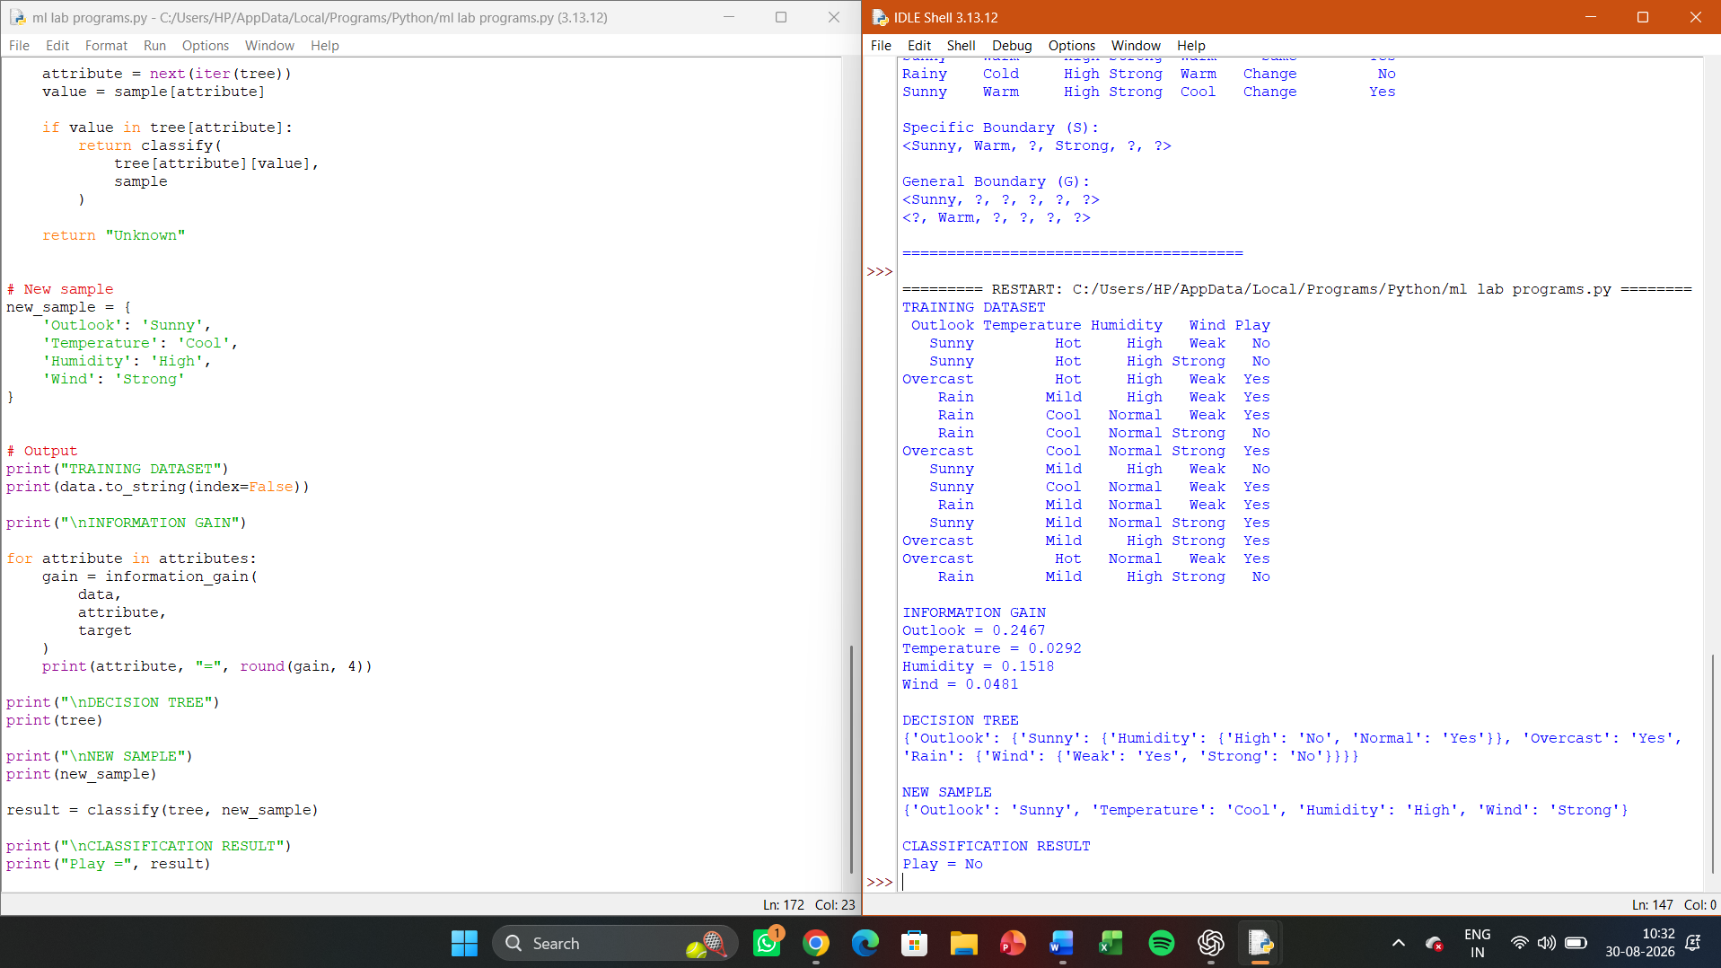

EXPERIMENT 4:
Build an Artificial Neural Network by implementing the Backpropagation algorithm and test the same using appropriate data sets.

Aim
To build an Artificial Neural Network (ANN) by implementing the Backpropagation algorithm and test its performance using a suitable dataset.
Procedure
- Initialize the input, hidden, and output layers.
- Initialize weights and biases with small random values.
- Apply the sigmoid activation function.
- Perform forward propagation to calculate the output.
- Calculate the error between the actual and predicted output.
- Propagate the error backward through the network.
- Calculate the gradients using the derivative of the activation function.
- Update the weights and biases using the learning rate.
- Repeat the process for the specified number of epochs.
- Test the trained ANN with the input dataset and calculate the classification accuracy.
Coding
import numpy as np

X = np.array([
[0, 0],
[0, 1],
[1, 0],
[1, 1]
], dtype=float)

Y = np.array([
[0],
[1],
[1],
[0]
], dtype=float)

def sigmoid(x):
return 1 / (1 + np.exp(-x))

def sigmoid_derivative(x):
return x * (1 - x)

np.random.seed(42)
W1 = np.random.uniform(-1, 1, (2, 4))
b1 = np.zeros((1, 4))
W2 = np.random.uniform(-1, 1, (4, 1))
b2 = np.zeros((1, 1))
learning_rate = 0.5
epochs = 10000

for epoch in range(epochs):

hidden_input = np.dot(X, W1) + b1
hidden_output = sigmoid(hidden_input)

output_input = np.dot(hidden_output, W2) + b2
output = sigmoid(output_input)

error = Y - output

output_delta = error * sigmoid_derivative(output)

hidden_error = np.dot(output_delta, W2.T)
hidden_delta = hidden_error * sigmoid_derivative(hidden_output)

W2 += learning_rate * np.dot(hidden_output.T, output_delta)
b2 += learning_rate * np.sum(output_delta, axis=0, keepdims=True)

W1 += learning_rate * np.dot(X.T, hidden_delta)
b1 += learning_rate * np.sum(hidden_delta, axis=0, keepdims=True)

if epoch % 1000 == 0:
mse = np.mean(error ** 2)
print("Epoch:", epoch, "MSE:", round(mse, 6))

hidden_input = np.dot(X, W1) + b1
hidden_output = sigmoid(hidden_input)

output_input = np.dot(hidden_output, W2) + b2
predictions = sigmoid(output_input)

predicted_classes = (predictions >= 0.5).astype(int)

accuracy = np.mean(predicted_classes == Y) * 100

print("\nInput\tTarget\tPredicted")

for i in range(len(X)):
print(
X[i].astype(int),
"\t",
int(Y[i][0]),
"\t",
int(predicted_classes[i][0])
)

print("\nAccuracy:", accuracy, "%")
Result
The Artificial Neural Network was successfully built using the Backpropagation algorithm and tested using the XOR dataset. The network learned the nonlinear XOR relationship and correctly classified the training samples with high accuracy.

Output
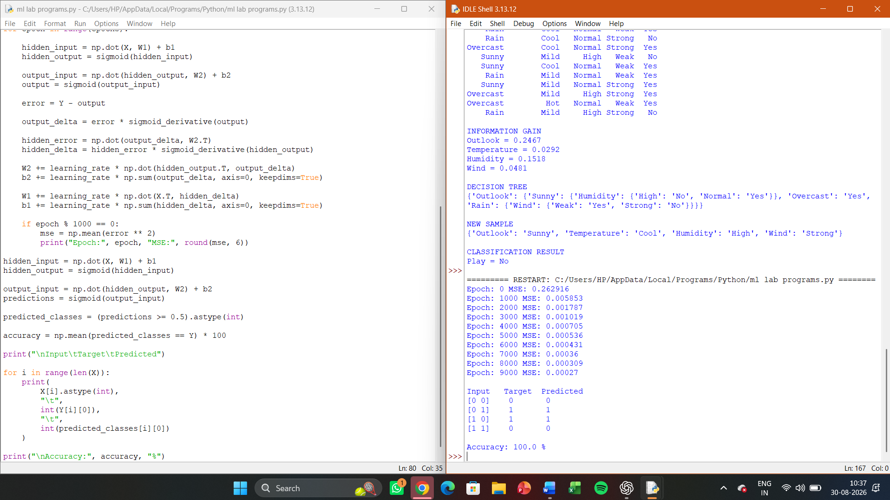

EXPERIMENT 5:
Write a program for Implementation of K-Nearest Neighbours (K-NN) in Python

Aim
To implement the K-Nearest Neighbours (K-NN) algorithm in Python and classify a new data sample based on its nearest neighbours.
Procedure
- Load a suitable dataset.
- Separate the input features and target class.
- Divide the dataset into training and testing data.
- Calculate the distance between the test sample and training samples.
- Select the K nearest neighbours.
- Determine the most frequent class among the neighbours.
- Assign that class to the test sample.
- Calculate the classification accuracy.
Coding
import numpy as np
from collections import Counter
from sklearn.model_selection import train_test_split
from sklearn.metrics import accuracy_score

X = np.array([
[1, 2],
[2, 3],
[3, 3],
[5, 5],
[6, 7],
[7, 8],
[8, 8],
[9, 9]
])

y = np.array([
'A',
'A',
'A',
'B',
'B',
'B',
'B',
'B'
])

X_train, X_test, y_train, y_test = train_test_split(
X, y, test_size=0.25, random_state=42
)

def knn_predict(X_train, y_train, X_test, k):
predictions = []

for test_point in X_test:
distances = np.sqrt(
np.sum((X_train - test_point) ** 2, axis=1)
)

nearest_indices = np.argsort(distances)[:k]

nearest_labels = y_train[nearest_indices]

prediction = Counter(nearest_labels).most_common(1)[0][0]

predictions.append(prediction)

return np.array(predictions)

k = 3

y_pred = knn_predict(X_train, y_train, X_test, k)

print("Training Data:")
print(X_train)

print("\nTesting Data:")
print(X_test)

print("\nActual Classes:")
print(y_test)

print("\nPredicted Classes:")
print(y_pred)

accuracy = accuracy_score(y_test, y_pred)

print("\nAccuracy:", accuracy * 100, "%")

new_sample = np.array([[4, 4]])

new_prediction = knn_predict(
X_train,
y_train,
new_sample,
k
)

print("\nNew Sample:", new_sample[0])
print("Predicted Class:", new_prediction[0])
Result
The K-Nearest Neighbours (K-NN) algorithm was successfully implemented in Python. The program calculates the nearest neighbours using Euclidean distance and classifies the new sample based on the majority class of its nearest neighbours.

OUTPUT
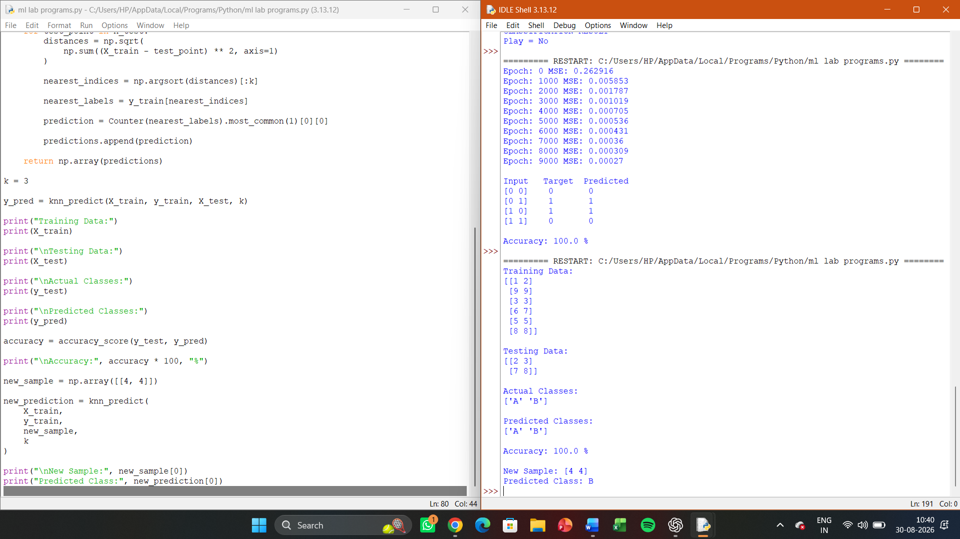

EXPERIMENT 6:
Aim
To implement the Naïve Bayes classification algorithm in Python and evaluate its performance using a confusion matrix and accuracy.
Procedure
- Load a suitable dataset.
- Separate the input features and target class.
- Split the dataset into training and testing sets.
- Train the Naïve Bayes classifier using the training data.
- Predict the classes of the test data.
- Generate the confusion matrix.
- Calculate and display the classification accuracy.
Coding
import numpy as np
from sklearn.model_selection import train_test_split
from sklearn.naive_bayes import GaussianNB
from sklearn.metrics import confusion_matrix, accuracy_score

X = np.array([
[1, 2],
[2, 3],
[2, 2],
[3, 4],
[4, 5],
[5, 6],
[6, 7],
[7, 8],
[8, 9],
[9, 10]
])

y = np.array([
0, 0, 0, 0, 0,
1, 1, 1, 1, 1
])

X_train, X_test, y_train, y_test = train_test_split(
X, y,
test_size=0.3,
random_state=42,
stratify=y
)
model = GaussianNB()
model.fit(X_train, y_train)
y_pred = model.predict(X_test)

cm = confusion_matrix(y_test, y_pred)

accuracy = accuracy_score(y_test, y_pred)

print("Actual Values:")
print(y_test)

print("\nPredicted Values:")
print(y_pred)

print("\nConfusion Matrix:")
print(cm)

print("\nAccuracy:")
print(accuracy * 100, "%")
Result
The Naïve Bayes algorithm was successfully implemented in Python. The program classified the test samples and displayed the confusion matrix and classification accuracy.

OUTPUT
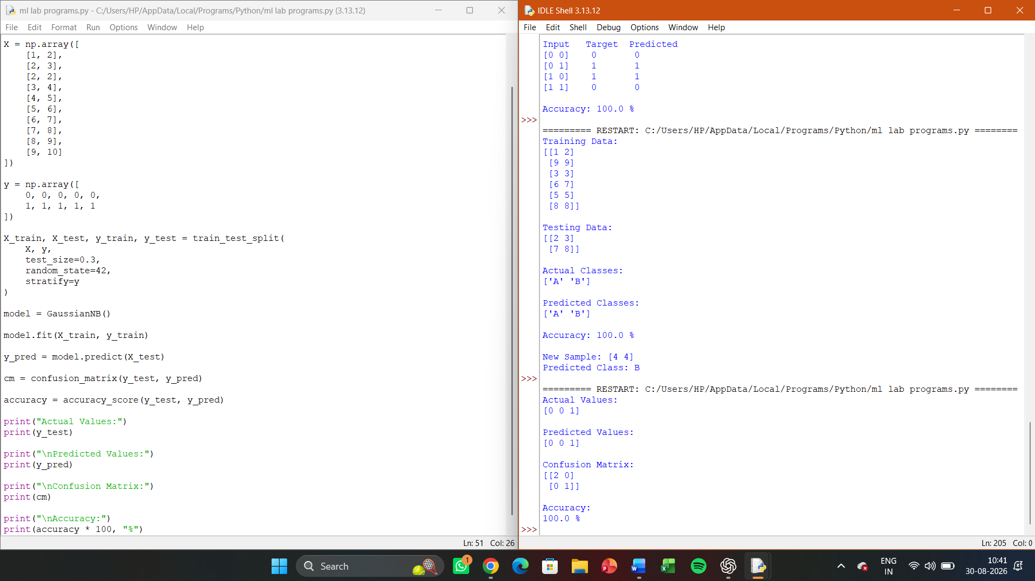
EXPERIMENT 7:
Write a program to implement Logistic Regression (LR) algorithm in python

Aim
To implement the Logistic Regression (LR) algorithm in Python for binary classification and predict the class of new data samples.
Procedure
- Load a suitable dataset.
- Separate the input features and target variable.
- Split the dataset into training and testing data.
- Create the Logistic Regression model.
- Train the model using the training data.
- Predict the classes for the test data.
- Calculate the accuracy of the model.
- Predict the class of a new sample.
Coding
import numpy as np
from sklearn.model_selection import train_test_split
from sklearn.linear_model import LogisticRegression
from sklearn.metrics import accuracy_score, confusion_matrix

X = np.array([
[1, 2],
[2, 3],
[2, 2],
[3, 4],
[4, 5],
[5, 6],
[6, 7],
[7, 8],
[8, 9],
[9, 10]
])

y = np.array([
0, 0, 0, 0, 0,
1, 1, 1, 1, 1
])

X_train, X_test, y_train, y_test = train_test_split(
X, y,
test_size=0.3,
random_state=42,
stratify=y
)

model = LogisticRegression()

model.fit(X_train, y_train)

y_pred = model.predict(X_test)

accuracy = accuracy_score(y_test, y_pred)

cm = confusion_matrix(y_test, y_pred)

print("Actual Values:")
print(y_test)

print("\nPredicted Values:")
print(y_pred)

print("\nConfusion Matrix:")
print(cm)

print("\nAccuracy:")
print(accuracy * 100, "%")

new_sample = np.array([[4, 4]])

prediction = model.predict(new_sample)

print("\nNew Sample:")
print(new_sample)

print("\nPredicted Class:")
print(prediction[0])
Result
The Logistic Regression algorithm was successfully implemented in Python. The model classified the test samples and displayed the predicted classes, confusion matrix, and accuracy.

OUTPUT:
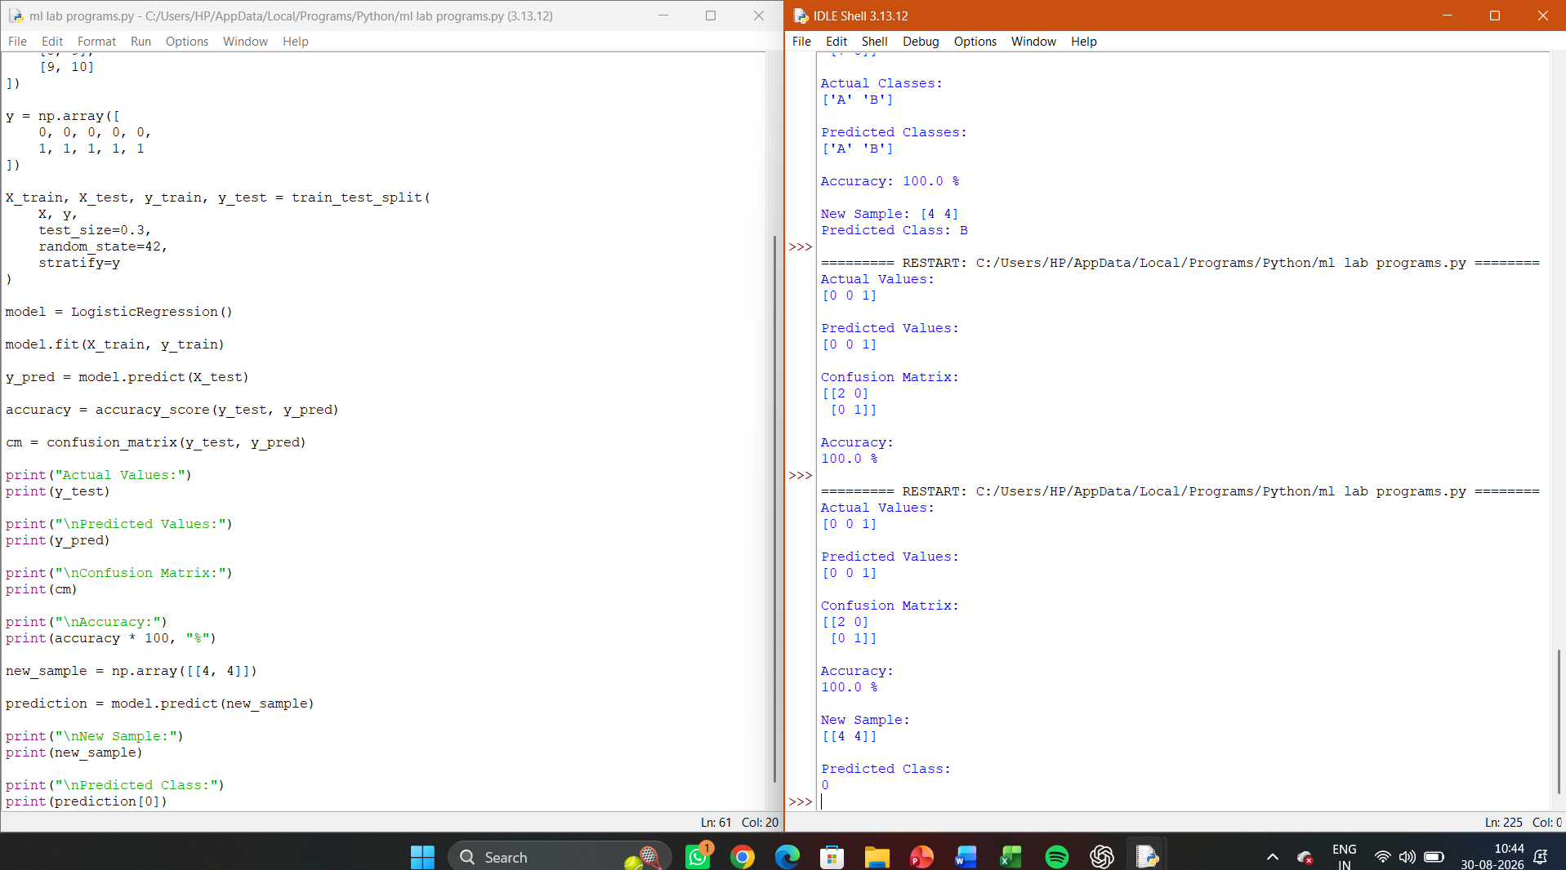

EXPERIMENT 8:
Write a program to implement Linear Regression (LR) algorithm in python

Aim
To implement the Linear Regression (LR) algorithm in Python and predict the dependent variable from a given independent variable.
Procedure
- Create a suitable dataset containing input and output values.
- Separate the independent and dependent variables.
- Split the dataset into training and testing data.
- Create and train the Linear Regression model.
- Predict the output for the test data.
- Calculate the model accuracy using Mean Squared Error and R² score.
- Predict the output for a new sample.
Coding
import numpy as np
from sklearn.model_selection import train_test_split
from sklearn.linear_model import LinearRegression
from sklearn.metrics import mean_squared_error, r2_score
X = np.array([
[1],
[2],
[3],
[4],
[5],
[6],
[7],
[8],
[9],
[10]
])
y = np.array([
2,
4,
6,
8,
10,
12,
14,
16,
18,
20
])
X_train, X_test, y_train, y_test = train_test_split(
X,
y,
test_size=0.3,
random_state=42
)
model = LinearRegression()
model.fit(X_train, y_train)
y_pred = model.predict(X_test)
mse = mean_squared_error(y_test, y_pred)
r2 = r2_score(y_test, y_pred)
print("Actual Values:")
print(y_test)
print("\nPredicted Values:")
print(y_pred)
print("\nMean Squared Error:")
print(mse)

print("\nR2 Score:")
print(r2)

print("\nRegression Equation:")
print("y =", round(model.coef_[0], 2), "x +", round(model.intercept_, 2))

new_sample = np.array([[12]])

prediction = model.predict(new_sample)

print("\nNew Sample:")
print(new_sample[0][0])

print("\nPredicted Value:")
print(prediction[0])
Result
The Linear Regression algorithm was successfully implemented in Python. The model learned the linear relationship between the input and output variables and successfully predicted the output for a new sample.

OUTPUT
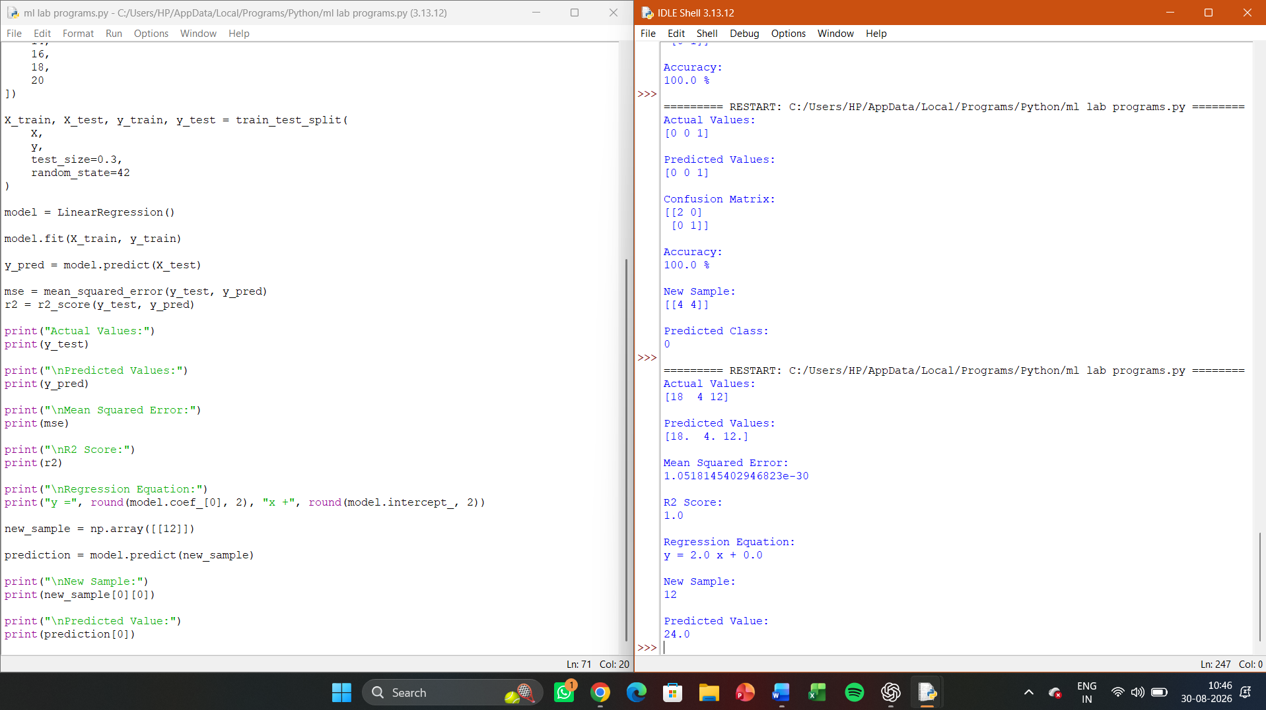

EXPERIMENT 9:
Compare Linear and Polynomial Regression using Python

Aim
To implement and compare Linear Regression and Polynomial Regression in Python using a suitable dataset and evaluate their performance using Mean Squared Error (MSE) and R² Score.
Procedure
- Create a dataset containing input and output values.
- Split the dataset into training and testing data.
- Train a Linear Regression model.
- Transform the input features into polynomial features.
- Train a Polynomial Regression model.
- Predict the output using both models.
- Calculate MSE and R² Score.
- Compare the performance of both models.
Coding
import numpy as np
import matplotlib.pyplot as plt
from sklearn.model_selection import train_test_split
from sklearn.linear_model import LinearRegression
from sklearn.preprocessing import PolynomialFeatures
from sklearn.metrics import mean_squared_error, r2_score

X = np.array([
[1], [2], [3], [4], [5],
[6], [7], [8], [9], [10],
[11], [12], [13], [14], [15]
])

y = np.array([
3, 5, 8, 12, 17,
23, 30, 38, 47, 57,
68, 80, 93, 107, 122
])

X_train, X_test, y_train, y_test = train_test_split(
X, y, test_size=0.3, random_state=42
)

linear_model = LinearRegression()
linear_model.fit(X_train, y_train)

linear_pred = linear_model.predict(X_test)

linear_mse = mean_squared_error(y_test, linear_pred)
linear_r2 = r2_score(y_test, linear_pred)

poly = PolynomialFeatures(degree=2)

X_train_poly = poly.fit_transform(X_train)
X_test_poly = poly.transform(X_test)

poly_model = LinearRegression()
poly_model.fit(X_train_poly, y_train)

poly_pred = poly_model.predict(X_test_poly)

poly_mse = mean_squared_error(y_test, poly_pred)
poly_r2 = r2_score(y_test, poly_pred)

print("LINEAR REGRESSION")
print("MSE:", round(linear_mse, 4))
print("R2 Score:", round(linear_r2, 4))

print("\nPOLYNOMIAL REGRESSION")
print("MSE:", round(poly_mse, 4))
print("R2 Score:", round(poly_r2, 4))

print("\nCOMPARISON")

if poly_r2 > linear_r2:
print("Polynomial Regression performs better.")
else:
print("Linear Regression performs better.")

X_plot = np.linspace(1, 15, 100).reshape(-1, 1)

linear_plot = linear_model.predict(X_plot)

poly_plot = poly_model.predict(
poly.transform(X_plot)
)

plt.scatter(X, y, label="Data")
plt.plot(X_plot, linear_plot, label="Linear Regression")
plt.plot(X_plot, poly_plot, label="Polynomial Regression")
plt.xlabel("X")
plt.ylabel("Y")
plt.title("Linear vs Polynomial Regression")
plt.legend()
plt.show()
Result
The Linear Regression and Polynomial Regression models were successfully implemented and compared using MSE and R² score. Polynomial Regression provides a better fit for the nonlinear dataset, while Linear Regression represents the relationship using a straight line.

OUTPUT
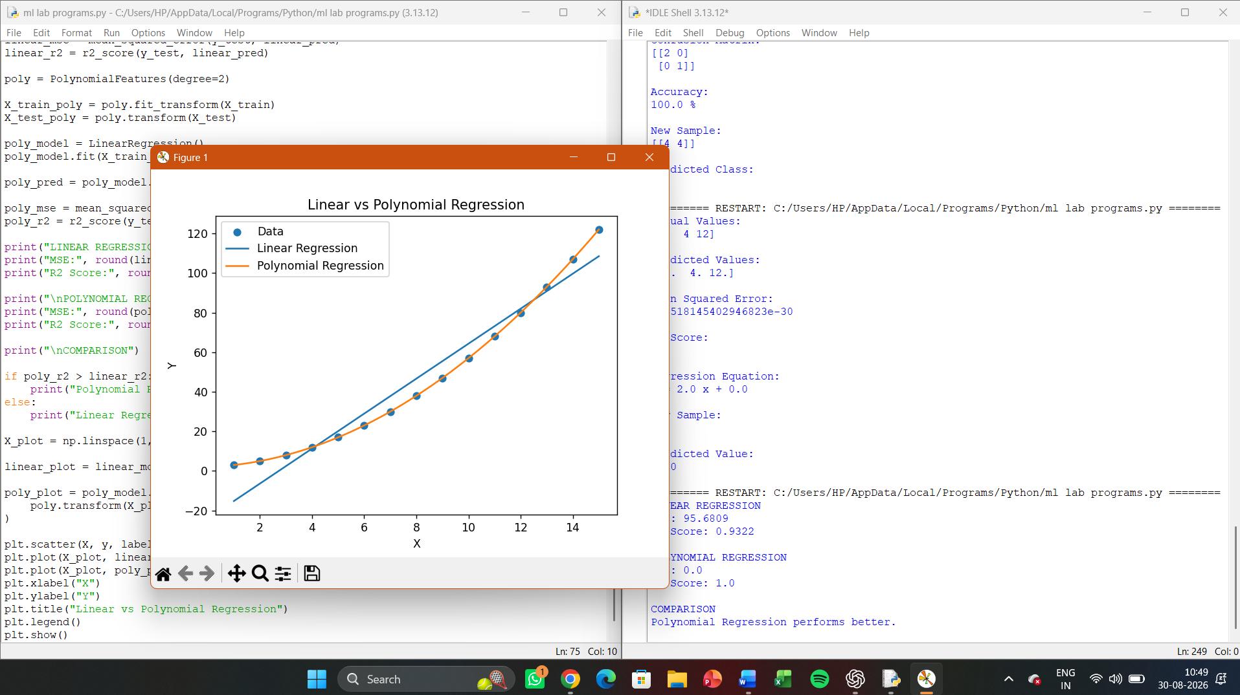

EXPERIMENT 10:
Write a Python Program to Implement Expectation & Maximization Algorithm

Aim
To implement the Expectation-Maximization (EM) algorithm in Python for clustering a given dataset into groups based on Gaussian probability distributions.
Procedure
- Generate or load the input dataset.
- Initialize the means, variances, and mixing probabilities.
- Perform the Expectation (E) step to calculate the probability that each data point belongs to each cluster.
- Perform the Maximization (M) step to update the means, variances, and mixing probabilities.
- Repeat the E-step and M-step until convergence.
- Assign each data point to the cluster with the highest probability.
- Display the final cluster assignments and parameters.

Coding
import numpy as np

np.random.seed(42)

X = np.array([
1.0, 1.5, 2.0, 2.5, 3.0,
8.0, 8.5, 9.0, 9.5, 10.0
])

K = 2
n = len(X)

means = np.array([2.0, 9.0])
variances = np.array([1.0, 1.0])
weights = np.array([0.5, 0.5])

def gaussian(x, mean, variance):
return (
1 / np.sqrt(2 * np.pi * variance)
* np.exp(-(x - mean) ** 2 / (2 * variance))
)

for iteration in range(100):

responsibilities = np.zeros((n, K))

for i in range(n):
for k in range(K):
responsibilities[i, k] = (
weights[k]
* gaussian(X[i], means[k], variances[k])
)

total = np.sum(responsibilities[i])

if total > 0:
responsibilities[i] /= total

old_means = means.copy()

for k in range(K):

Nk = np.sum(responsibilities[:, k])

means[k] = np.sum(
responsibilities[:, k] * X
) / Nk

variances[k] = np.sum(
responsibilities[:, k]
* (X - means[k]) ** 2
) / Nk

weights[k] = Nk / n

if np.allclose(means, old_means, atol=1e-6):
break

clusters = np.argmax(responsibilities, axis=1)

print("Final Means:")
print(np.round(means, 4))

print("\nFinal Variances:")
print(np.round(variances, 4))

print("\nFinal Mixing Weights:")
print(np.round(weights, 4))

print("\nData Point\tCluster")

for i in range(n):
print(
X[i],
"\t\t",
clusters[i] + 1
)

print("\nNumber of Iterations:", iteration + 1)

OUTPUT:
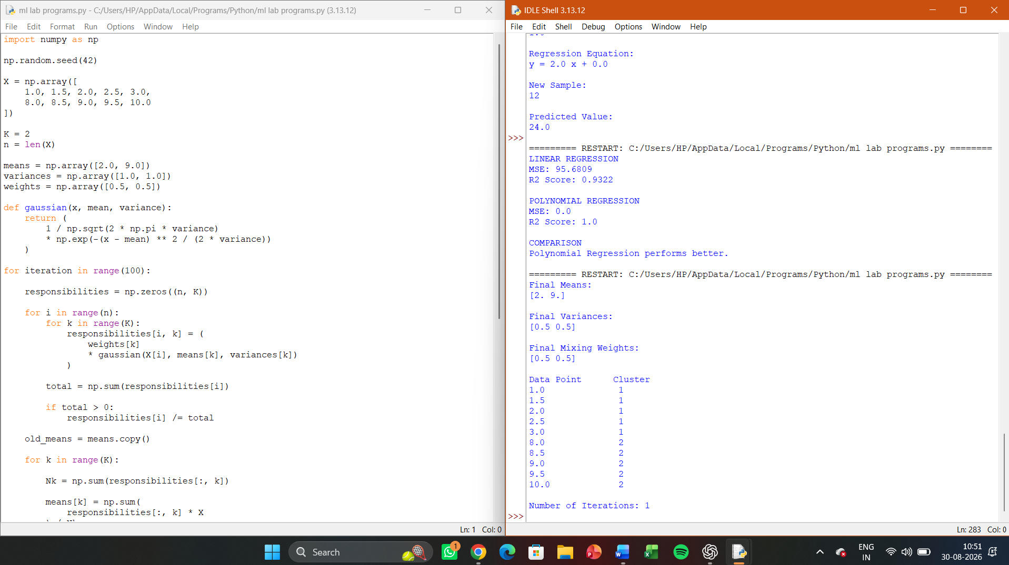

EXPERIMENT 11:
Write a program for the task of Credit Score Classification

Aim
To implement a Credit Score Classification program in Python using a machine learning classification algorithm and predict the credit score category of customers based on their financial attributes.
Procedure
- Create a dataset containing customer financial information.
- Separate the input features and credit score category.
- Encode categorical data into numerical values.
- Split the dataset into training and testing data.
- Train a classification model.
- Predict the credit score category for test data.
- Calculate the classification accuracy.
- Predict the credit score category for a new customer.
Coding
import pandas as pd
from sklearn.model_selection import train_test_split
from sklearn.preprocessing import LabelEncoder
from sklearn.tree import DecisionTreeClassifier
from sklearn.metrics import accuracy_score, confusion_matrix

data = pd.DataFrame({
"Age": [22, 25, 28, 30, 35, 40, 45, 50, 55, 60,
24, 27, 32, 38, 43, 48, 53, 58, 29, 36],

"Income": [20000, 25000, 30000, 35000, 45000,
50000, 60000, 70000, 80000, 90000,
22000, 28000, 38000, 48000, 55000,
65000, 75000, 85000, 32000, 42000],

"LoanAmount": [15000, 18000, 20000, 25000, 30000,
28000, 35000, 40000, 45000, 50000,
16000, 19000, 22000, 27000, 32000,
36000, 42000, 46000, 23000, 29000],

"CreditHistory": [0, 0, 1, 1, 1,
1, 1, 1, 1, 1,
0, 1, 1, 1, 1,
1, 1, 1, 0, 1],

"DebtRatio": [0.80, 0.75, 0.60, 0.55, 0.45,
0.40, 0.35, 0.30, 0.25, 0.20,
0.78, 0.62, 0.50, 0.42, 0.38,
0.32, 0.28, 0.22, 0.58, 0.44],

"CreditScore": [
"Poor", "Poor", "Poor", "Average", "Average",
"Good", "Good", "Good", "Good", "Good",
"Poor", "Poor", "Average", "Average", "Good",
"Good", "Good", "Good", "Average", "Average"
]
})

X = data.drop("CreditScore", axis=1)
y = data["CreditScore"]

encoder = LabelEncoder()
y = encoder.fit_transform(y)

X_train, X_test, y_train, y_test = train_test_split(
X, y,
test_size=0.3,
random_state=42,
stratify=y
)

model = DecisionTreeClassifier(
criterion="entropy",
random_state=42
)

model.fit(X_train, y_train)

y_pred = model.predict(X_test)

accuracy = accuracy_score(y_test, y_pred)
cm = confusion_matrix(y_test, y_pred)

print("CREDIT SCORE CLASSIFICATION")
print("\nTraining Samples:", len(X_train))
print("Testing Samples:", len(X_test))

print("\nActual Values:")
print(encoder.inverse_transform(y_test))

print("\nPredicted Values:")
print(encoder.inverse_transform(y_pred))

print("\nConfusion Matrix:")
print(cm)

print("\nAccuracy:")
print(accuracy * 100, "%")

new_customer = pd.DataFrame({
"Age": [31],
"Income": [40000],
"LoanAmount": [25000],
"CreditHistory": [1],
"DebtRatio": [0.45]
})

prediction = model.predict(new_customer)

print("\nNew Customer:")
print(new_customer)

print("\nPredicted Credit Score:")
print(encoder.inverse_transform(prediction)[0])

OUTPUT

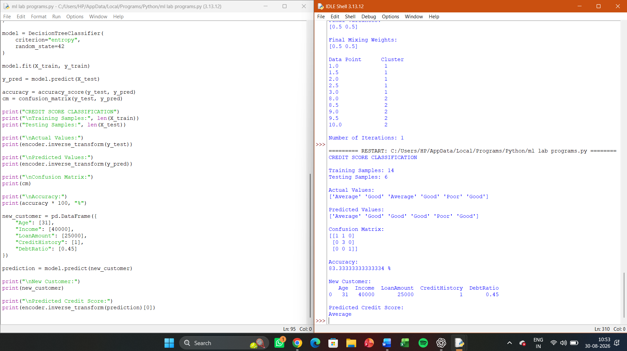

EXPERIMENT 12:
Implement Iris Flower Classification using KNN

Aim
To implement Iris Flower Classification using the K-Nearest Neighbours (KNN) algorithm in Python and classify iris flowers into different species.
Procedure
- Load the Iris dataset.
- Separate the input features and target classes.
- Split the dataset into training and testing data.
- Apply feature scaling.
- Train the KNN classifier.
- Predict the classes of the test samples.
- Calculate the accuracy and display the confusion matrix.
- Classify a new iris flower sample.
Coding
from sklearn.datasets import load_iris
from sklearn.model_selection import train_test_split
from sklearn.preprocessing import StandardScaler
from sklearn.neighbors import KNeighborsClassifier
from sklearn.metrics import accuracy_score, confusion_matrix, classification_report

iris = load_iris()

X = iris.data
y = iris.target

X_train, X_test, y_train, y_test = train_test_split(
X, y,
test_size=0.2,
random_state=42,
stratify=y
)

scaler = StandardScaler()

X_train = scaler.fit_transform(X_train)
X_test = scaler.transform(X_test)

k = 5

model = KNeighborsClassifier(n_neighbors=k)

model.fit(X_train, y_train)

y_pred = model.predict(X_test)

accuracy = accuracy_score(y_test, y_pred)

cm = confusion_matrix(y_test, y_pred)

print("IRIS FLOWER CLASSIFICATION USING KNN")

print("\nActual Classes:")
print(iris.target_names[y_test])

print("\nPredicted Classes:")
print(iris.target_names[y_pred])

print("\nConfusion Matrix:")
print(cm)

print("\nAccuracy:")
print(accuracy * 100, "%")

print("\nClassification Report:")
print(classification_report(
y_test,
y_pred,
target_names=iris.target_names
))

new_flower = [[
5.1,
3.5,
1.4,
0.2
]]

new_flower_scaled = scaler.transform(new_flower)

prediction = model.predict(new_flower_scaled)

print("\nNew Flower Measurements:")
print(new_flower)

print("\nPredicted Species:")
print(iris.target_names[prediction][0])
Result
The Iris Flower Classification using KNN was successfully implemented. The program classifies iris flowers into Setosa, Versicolor, and Virginica and displays the accuracy, confusion matrix, and predicted class of a new flower sample.

OUTPUT:
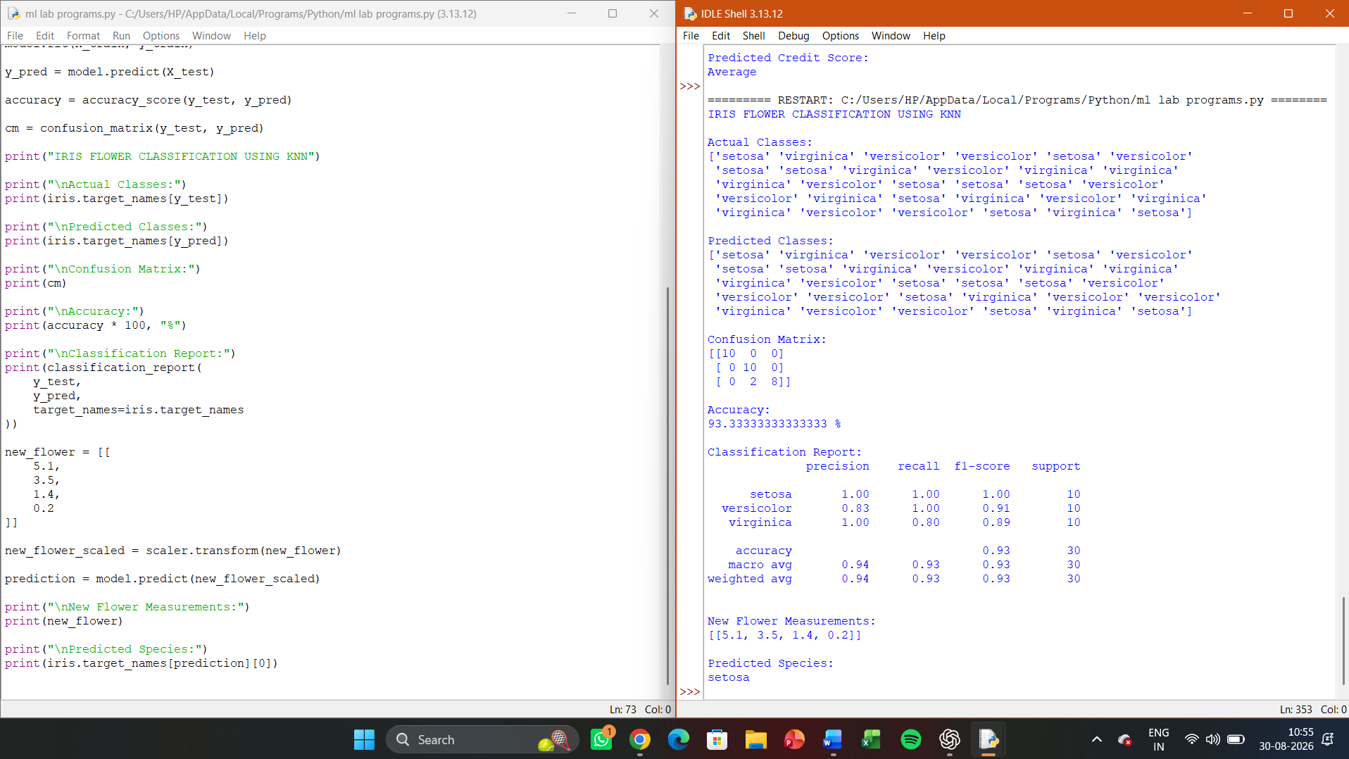

EXPERIMENT 13:
Implement the Car Price Prediction Model using Python

Aim
To implement a Car Price Prediction Model in Python using Linear Regression and predict the selling price of a car based on its features.
Procedure
- Create a car dataset with features such as year, present price, kilometers driven, and fuel type.
- Encode categorical features into numerical values.
- Separate input features and target price.
- Split the dataset into training and testing data.
- Train the Linear Regression model.
- Predict car prices for the test data.
- Calculate the model performance using MSE and R² score.
- Predict the price of a new car.
Coding
import pandas as pd
from sklearn.model_selection import train_test_split
from sklearn.preprocessing import LabelEncoder
from sklearn.linear_model import LinearRegression
from sklearn.metrics import mean_squared_error, r2_score

data = pd.DataFrame({
"Year": [2015, 2016, 2017, 2018, 2019, 2020, 2021, 2022, 2017, 2019,
2016, 2018, 2020, 2021, 2022],
"Present_Price": [5.5, 6.0, 7.5, 8.0, 9.5, 10.0, 12.0, 14.0,
7.0, 9.0, 6.5, 8.5, 11.0, 13.0, 15.0],
"Kms_Driven": [50000, 45000, 40000, 35000, 30000, 25000, 20000, 15000,
42000, 32000, 46000, 36000, 28000, 22000, 12000],
"Fuel_Type": ["Petrol", "Petrol", "Diesel", "Petrol", "Diesel",
"Petrol", "Diesel", "Diesel", "Petrol", "Diesel",
"Petrol", "Petrol", "Diesel", "Diesel", "Petrol"],
"Selling_Price": [3.5, 4.0, 5.5, 6.2, 7.5, 8.0, 9.5, 11.5,
5.0, 7.0, 4.3, 6.5, 8.8, 10.5, 12.0]
})

encoder = LabelEncoder()
data["Fuel_Type"] = encoder.fit_transform(data["Fuel_Type"])

X = data.drop("Selling_Price", axis=1)
y = data["Selling_Price"]

X_train, X_test, y_train, y_test = train_test_split(
X, y,
test_size=0.2,
random_state=42
)

model = LinearRegression()

model.fit(X_train, y_train)

y_pred = model.predict(X_test)

mse = mean_squared_error(y_test, y_pred)
r2 = r2_score(y_test, y_pred)

print("CAR PRICE PREDICTION")

print("\nActual Prices:")
print(y_test.values)

print("\nPredicted Prices:")
print(y_pred)

print("\nMean Squared Error:")
print(round(mse, 4))

print("\nR2 Score:")
print(round(r2, 4))

new_car = pd.DataFrame({
"Year": [2021],
"Present_Price": [12.0],
"Kms_Driven": [18000],
"Fuel_Type": [
encoder.transform(["Diesel"])[0]
]
})

prediction = model.predict(new_car)

print("\nNew Car Details:")
print(new_car)

print("\nPredicted Selling Price:")
print(round(prediction[0], 2), "Lakhs")
Result
The Car Price Prediction Model was successfully implemented using Linear Regression. The model predicts the selling price based on car features and evaluates its performance using MSE and R² score.

OUTPUT:

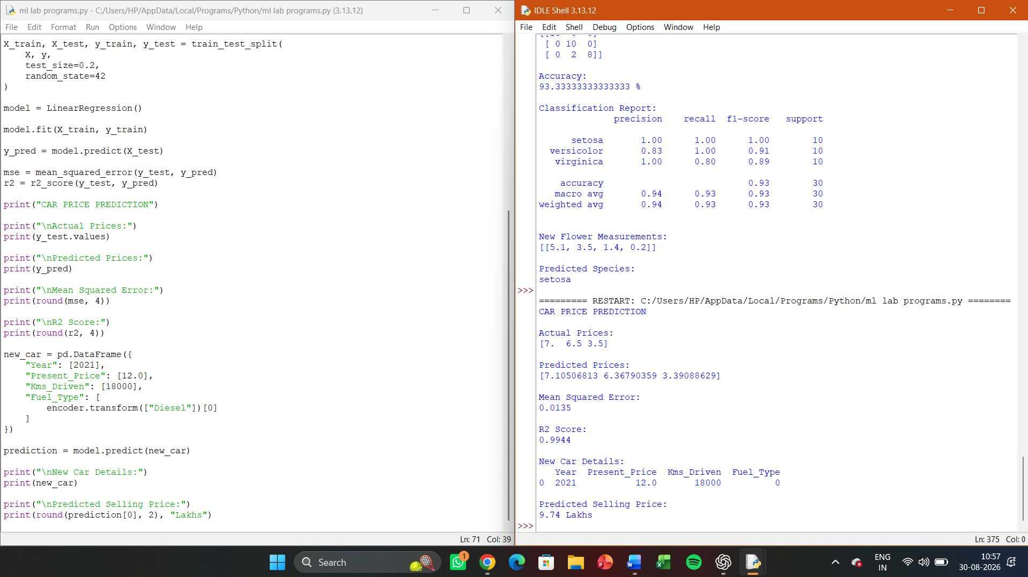

EXPERIMENT 14:
Implement House price Prediction using appropriate machine learning algorithm

Aim
To implement a House Price Prediction model in Python using an appropriate machine learning algorithm and predict the price of a house based on its features.
Procedure
- Create a dataset containing house features such as area, bedrooms, bathrooms, age, and location.
- Convert categorical data into numerical values.
- Separate input features and house price.
- Split the dataset into training and testing sets.
- Train a Random Forest Regression model.
- Predict house prices for the test data.
- Evaluate the model using Mean Squared Error (MSE) and R² Score.
- Predict the price of a new house.
Coding
import pandas as pd
from sklearn.model_selection import train_test_split
from sklearn.preprocessing import LabelEncoder
from sklearn.ensemble import RandomForestRegressor
from sklearn.metrics import mean_squared_error, r2_score

data = pd.DataFrame({
"Area": [800, 1000, 1200, 1400, 1600, 1800, 2000, 2200,
900, 1100, 1300, 1500, 1700, 1900, 2100],
"Bedrooms": [2, 2, 3, 3, 3, 4, 4, 4,
2, 3, 3, 3, 4, 4, 4],
"Bathrooms": [1, 1, 2, 2, 2, 2, 3, 3,
1, 2, 2, 2, 2, 3, 3],
"Age": [20, 18, 15, 12, 10, 8, 5, 3,
22, 16, 13, 11, 7, 6, 4],
"Location": [
"Urban", "Urban", "Urban", "Suburban", "Suburban",
"Urban", "Urban", "Suburban", "Rural", "Rural",
"Suburban", "Suburban", "Urban", "Urban", "Suburban"
],
"Price": [
35, 42, 55, 65, 75, 90, 110, 125,
38, 48, 60, 70, 85, 100, 115
]
})

encoder = LabelEncoder()

data["Location"] = encoder.fit_transform(data["Location"])

X = data.drop("Price", axis=1)
y = data["Price"]

X_train, X_test, y_train, y_test = train_test_split(
X,
y,
test_size=0.2,
random_state=42
)

model = RandomForestRegressor(
n_estimators=100,
random_state=42
)

model.fit(X_train, y_train)

y_pred = model.predict(X_test)

mse = mean_squared_error(y_test, y_pred)
r2 = r2_score(y_test, y_pred)

print("HOUSE PRICE PREDICTION")

print("\nActual Prices:")
print(y_test.values)

print("\nPredicted Prices:")
print(y_pred.round(2))

print("\nMean Squared Error:")
print(round(mse, 4))

print("\nR2 Score:")
print(round(r2, 4))

new_house = pd.DataFrame({
"Area": [1500],
"Bedrooms": [3],
"Bathrooms": [2],
"Age": [8],
"Location": [
encoder.transform(["Suburban"])[0]
]
})

prediction = model.predict(new_house)

print("\nNew House Details:")
print(new_house)

print("\nPredicted House Price:")
print(round(prediction[0], 2), "Lakhs")
Result
The House Price Prediction model was successfully implemented using the Random Forest Regression algorithm. The model predicts house prices based on area, number of bedrooms, bathrooms, age, and location, and evaluates the prediction using MSE and R² score.

OUTPUT:
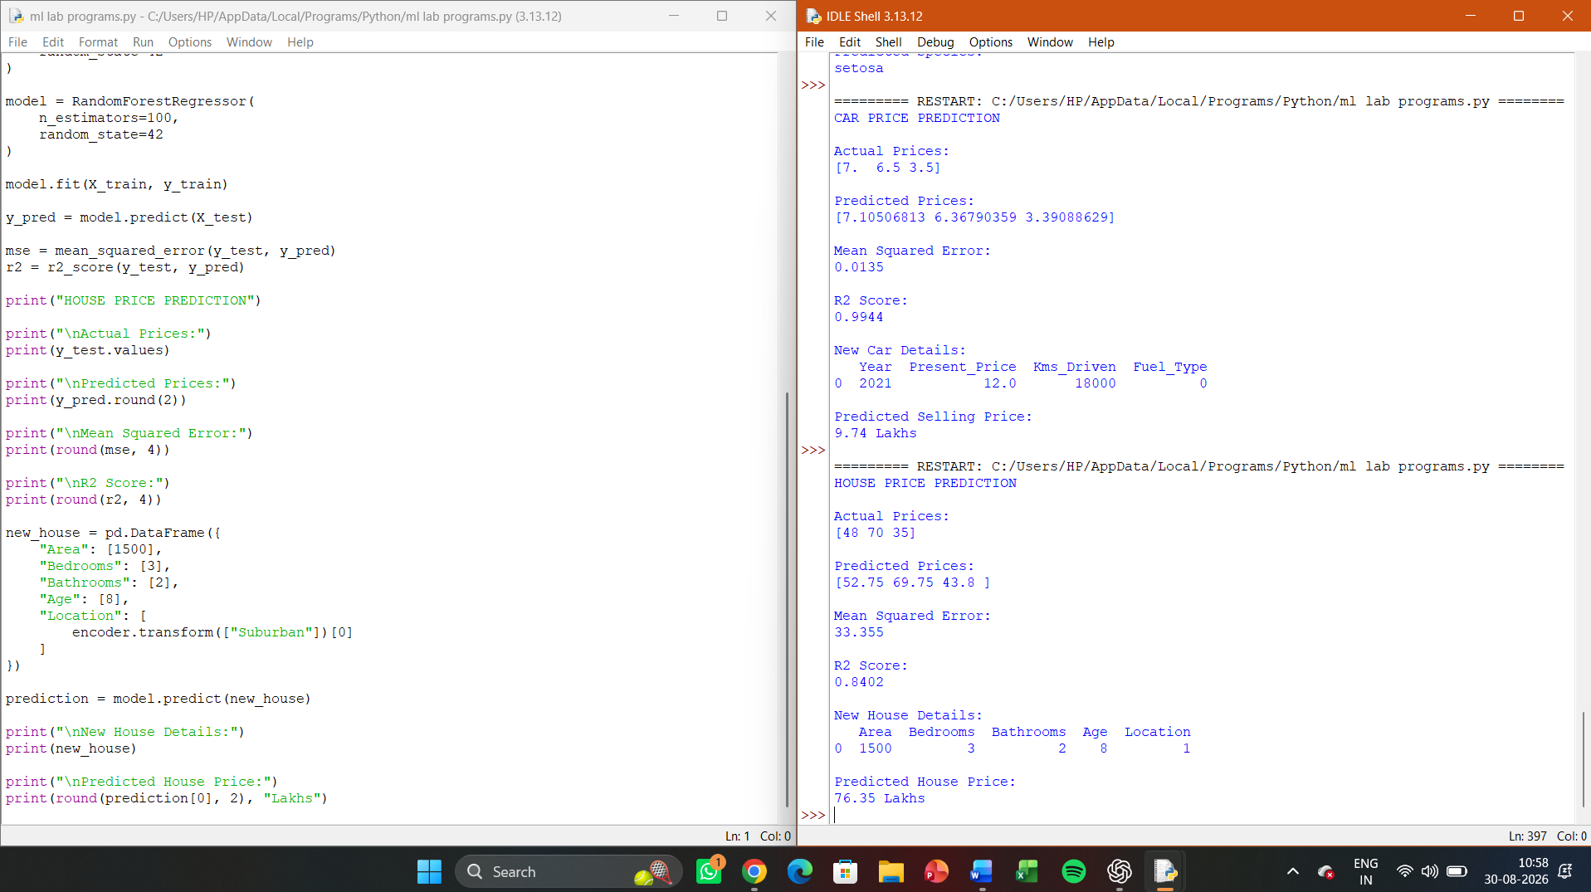

EXPERIMENT 15:

Implement Iris Flower Classification using Naive Bayes classifier

Aim
To implement Iris Flower Classification using the Naive Bayes classifier in Python and classify iris flowers into Setosa, Versicolor, and Virginica.
Procedure
- Load the Iris dataset.
- Separate the input features and target classes.
- Split the dataset into training and testing data.
- Train a Gaussian Naive Bayes classifier.
- Predict the classes of the test samples.
- Calculate the accuracy.
- Display the confusion matrix.
- Predict the species of a new iris flower.
Coding
from sklearn.datasets import load_iris
from sklearn.model_selection import train_test_split
from sklearn.naive_bayes import GaussianNB
from sklearn.metrics import accuracy_score, confusion_matrix, classification_report

iris = load_iris()

X = iris.data
y = iris.target

X_train, X_test, y_train, y_test = train_test_split(
X,
y,
test_size=0.2,
random_state=42,
stratify=y
)

model = GaussianNB()

model.fit(X_train, y_train)

y_pred = model.predict(X_test)

accuracy = accuracy_score(y_test, y_pred)

cm = confusion_matrix(y_test, y_pred)

print("IRIS FLOWER CLASSIFICATION USING NAIVE BAYES")

print("\nActual Classes:")
print(iris.target_names[y_test])

print("\nPredicted Classes:")
print(iris.target_names[y_pred])

print("\nConfusion Matrix:")
print(cm)

print("\nAccuracy:")
print(accuracy * 100, "%")

print("\nClassification Report:")
print(
classification_report(
y_test,
y_pred,
target_names=iris.target_names
)
)

new_flower = [[
5.1,
3.5,
1.4,
0.2
]]

prediction = model.predict(new_flower)

print("\nNew Flower:")
print(new_flower)

print("\nPredicted Species:")
print(iris.target_names[prediction][0])
Result
The Iris Flower Classification using Naive Bayes was successfully implemented. The classifier predicts the iris species and displays the confusion matrix, accuracy, and classification report.

OUTPUT:

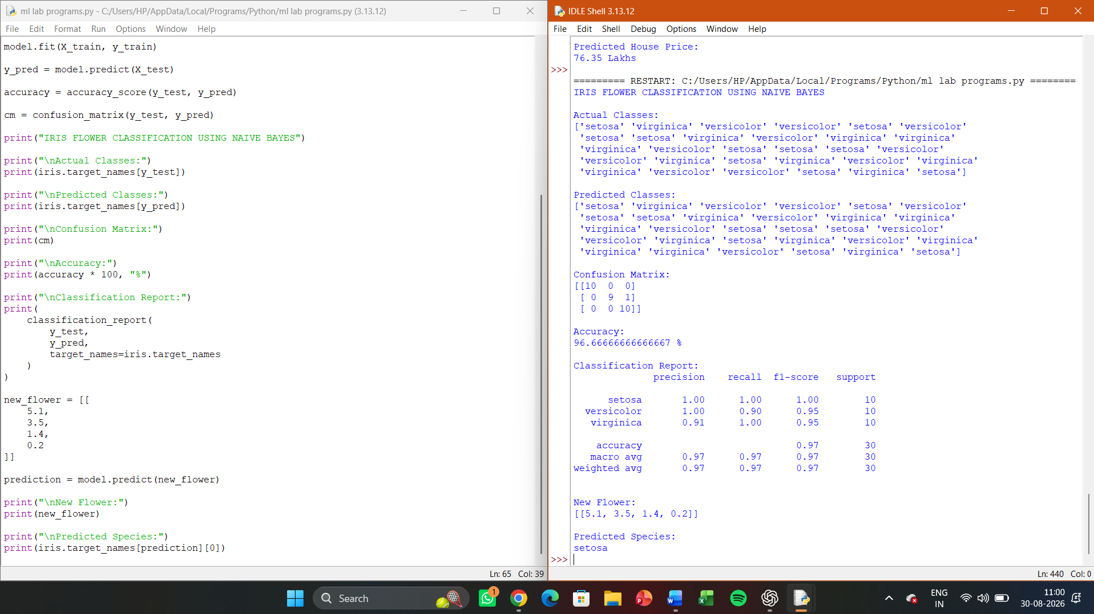

EXPERIMENT 16:
Compare different types Classification Algorithms and evaluate their performance.

Aim
To implement and compare different classification algorithms in Python and evaluate their performance using accuracy, precision, recall, F1-score, and confusion matrix.
Procedure
- Load the Iris dataset.
- Split the dataset into training and testing sets.
- Apply feature scaling where required.
- Implement different classification algorithms.
- Train each classifier using the training data.
- Predict the classes of the test data.
- Calculate accuracy, precision, recall, and F1-score.
- Compare the performance of all classification algorithms.
Coding
from sklearn.datasets import load_iris
from sklearn.model_selection import train_test_split
from sklearn.preprocessing import StandardScaler
from sklearn.linear_model import LogisticRegression
from sklearn.neighbors import KNeighborsClassifier
from sklearn.naive_bayes import GaussianNB
from sklearn.tree import DecisionTreeClassifier
from sklearn.ensemble import RandomForestClassifier
from sklearn.svm import SVC
from sklearn.metrics import accuracy_score, precision_score, recall_score, f1_score, confusion_matrix

iris = load_iris()

X = iris.data
y = iris.target

X_train, X_test, y_train, y_test = train_test_split(
X, y,
test_size=0.2,
random_state=42,
stratify=y
)

scaler = StandardScaler()

X_train_scaled = scaler.fit_transform(X_train)
X_test_scaled = scaler.transform(X_test)

models = {
"Logistic Regression": LogisticRegression(max_iter=1000),
"KNN": KNeighborsClassifier(n_neighbors=5),
"Naive Bayes": GaussianNB(),
"Decision Tree": DecisionTreeClassifier(random_state=42),
"Random Forest": RandomForestClassifier(
n_estimators=100,
random_state=42
),
"SVM": SVC()
}

print("CLASSIFICATION ALGORITHM COMPARISON")
print("=" * 75)

results = []

for name, model in models.items():

if name in ["Logistic Regression", "KNN", "SVM"]:
model.fit(X_train_scaled, y_train)
y_pred = model.predict(X_test_scaled)
else:
model.fit(X_train, y_train)
y_pred = model.predict(X_test)

accuracy = accuracy_score(y_test, y_pred)
precision = precision_score(
y_test,
y_pred,
average="weighted"
)
recall = recall_score(
y_test,
y_pred,
average="weighted"
)
f1 = f1_score(
y_test,
y_pred,
average="weighted"
)

results.append([
name,
accuracy * 100,
precision * 100,
recall * 100,
f1 * 100
])

print("\n", name)
print("Confusion Matrix:")
print(confusion_matrix(y_test, y_pred))
print("\n" + "=" * 75)
print("PERFORMANCE COMPARISON")
print("=" * 75)
print(
f"{'Algorithm':<22}"
f"{'Accuracy':<12}"
f"{'Precision':<12}"
f"{'Recall':<12}"
f"{'F1-Score':<12}"
)

for result in results:
print(
f"{result[0]:<22}"
f"{result[1]:<12.2f}"
f"{result[2]:<12.2f}"
f"{result[3]:<12.2f}"
f"{result[4]:<12.2f}"
)
best_model = max(results, key=lambda x: x[1])
print("\nBest Performing Algorithm:")
print(best_model[0])
print("Best Accuracy:")
print(round(best_model[1], 2), "%")
Result
Different classification algorithms such as Logistic Regression, KNN, Naive Bayes, Decision Tree, Random Forest, and SVM were successfully implemented and compared using the Iris dataset. Their performance was evaluated using accuracy, precision, recall, F1-score, and confusion matrix, and the algorithm with the highest accuracy was identified.

OUTPUT:
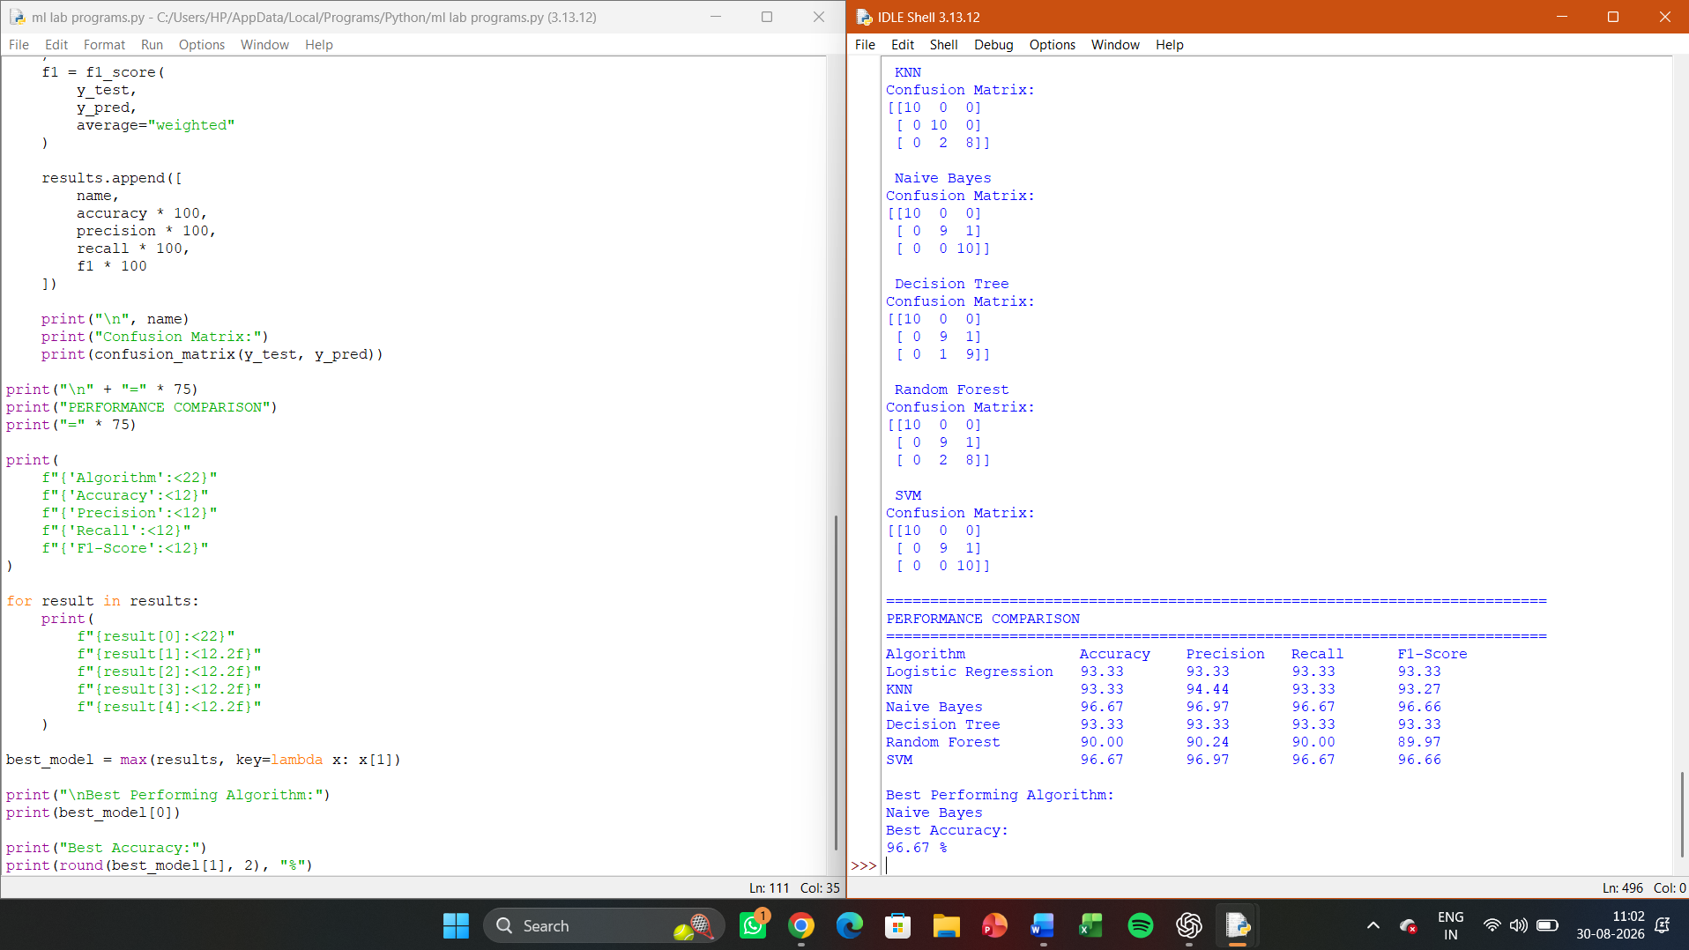

EXPERIMENT 17
Implement Mobile Price Prediction using appropriate machine learning algorithm

Aim
To implement a Mobile Price Prediction model in Python using an appropriate machine learning algorithm and classify mobile phones into different price ranges based on their specifications.
Procedure
- Create a dataset containing mobile specifications.
- Separate the input features and price-range class.
- Split the dataset into training and testing data.
- Train a Random Forest Classifier.
- Predict the price range of test samples.
- Calculate the accuracy and confusion matrix.
- Predict the price range of a new mobile phone.
Coding
import pandas as pd
from sklearn.model_selection import train_test_split
from sklearn.ensemble import RandomForestClassifier
from sklearn.metrics import accuracy_score, confusion_matrix, classification_report

data = pd.DataFrame({
"RAM": [2, 2, 3, 3, 4, 4, 6, 6, 8, 8, 12, 12, 4, 6, 8, 2, 3, 4, 6, 8],
"Storage": [32, 32, 64, 64, 64, 128, 128, 128, 128, 256,
256, 512, 128, 128, 256, 32, 64, 64, 128, 256],
"Battery": [3000, 3500, 3500, 4000, 4000, 4500, 4500, 5000,
5000, 5000, 5000, 6000, 4200, 4800, 5200, 3000,
3600, 4100, 4600, 5100],
"Camera": [8, 12, 12, 16, 16, 24, 32, 48, 48, 64,
108, 108, 50, 64, 108, 8, 13, 16, 48, 64],
"Screen": [5.0, 5.2, 5.5, 5.5, 6.0, 6.1, 6.2, 6.4,
6.5, 6.7, 6.7, 6.8, 6.1, 6.5, 6.7, 5.1,
5.6, 6.0, 6.4, 6.6],
"Price_Range": [
0, 0, 0, 0, 1, 1, 1, 1, 2, 2,
3, 3, 1, 2, 3, 0, 0, 1, 2, 3
]
})

X = data.drop("Price_Range", axis=1)
y = data["Price_Range"]

X_train, X_test, y_train, y_test = train_test_split(
X,
y,
test_size=0.25,
random_state=42,
stratify=y
)

model = RandomForestClassifier(
n_estimators=100,
random_state=42
)

model.fit(X_train, y_train)

y_pred = model.predict(X_test)

accuracy = accuracy_score(y_test, y_pred)

cm = confusion_matrix(y_test, y_pred)

print("MOBILE PRICE PREDICTION")

print("\nActual Price Ranges:")
print(y_test.values)

print("\nPredicted Price Ranges:")
print(y_pred)

print("\nConfusion Matrix:")
print(cm)

print("\nAccuracy:")
print(accuracy * 100, "%")

print("\nClassification Report:")
print(
classification_report(
y_test,
y_pred,
zero_division=0
)
)

new_mobile = pd.DataFrame({
"RAM": [8],
"Storage": [256],
"Battery": [5000],
"Camera": [64],
"Screen": [6.5]
})

prediction = model.predict(new_mobile)

price_ranges = {
0: "Low Price",
1: "Medium Price",
2: "High Price",
3: "Very High Price"
}

print("\nNew Mobile Specifications:")
print(new_mobile)

print("\nPredicted Price Range:")
print(price_ranges[prediction[0]])
Result
The Mobile Price Prediction model was successfully implemented using the Random Forest Classifier. The model predicts the mobile price range based on RAM, storage, battery capacity, camera, and screen size, and evaluates the performance using accuracy, confusion matrix, precision, recall, and F1-score.

OUTPUT:

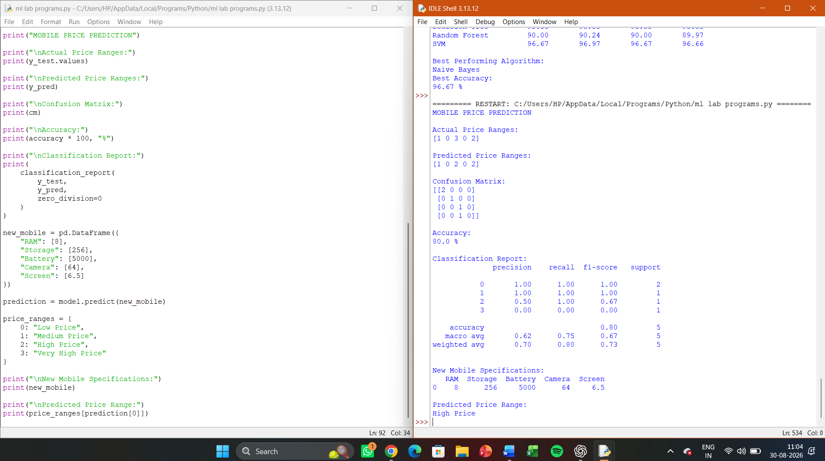

EXPERIMENT 18:
Implement Perceptron based IRIS classification

Aim
To implement Iris Flower Classification using the Perceptron algorithm in Python and classify iris flowers into different species.
Procedure
- Load the Iris dataset.
- Select the input features and target classes.
- Split the dataset into training and testing sets.
- Standardize the feature values.
- Train the Perceptron classifier.
- Predict the classes of the test samples.
- Calculate the classification accuracy.
- Display the confusion matrix and classification report.
Coding
from sklearn.datasets import load_iris
from sklearn.model_selection import train_test_split
from sklearn.preprocessing import StandardScaler
from sklearn.linear_model import Perceptron
from sklearn.metrics import accuracy_score, confusion_matrix, classification_report

iris = load_iris()

X = iris.data
y = iris.target

X_train, X_test, y_train, y_test = train_test_split(
X,
y,
test_size=0.2,
random_state=42,
stratify=y
)

scaler = StandardScaler()

X_train = scaler.fit_transform(X_train)
X_test = scaler.transform(X_test)

model = Perceptron(
max_iter=1000,
eta0=0.1,
random_state=42
)

model.fit(X_train, y_train)

y_pred = model.predict(X_test)

accuracy = accuracy_score(y_test, y_pred)

cm = confusion_matrix(y_test, y_pred)

print("IRIS CLASSIFICATION USING PERCEPTRON")

print("\nActual Classes:")
print(iris.target_names[y_test])

print("\nPredicted Classes:")
print(iris.target_names[y_pred])

print("\nConfusion Matrix:")
print(cm)

print("\nAccuracy:")
print(accuracy * 100, "%")

print("\nClassification Report:")
print(
classification_report(
y_test,
y_pred,
target_names=iris.target_names
)
)

new_flower = [[
5.1,
3.5,
1.4,
0.2
]]

new_flower_scaled = scaler.transform(new_flower)

prediction = model.predict(new_flower_scaled)

print("\nNew Flower Measurements:")
print(new_flower)

print("\nPredicted Species:")
print(iris.target_names[prediction][0])
Result
The Perceptron-based Iris classification was successfully implemented. The model classified the Iris flowers into Setosa, Versicolor, and Virginica and evaluated its performance using accuracy, confusion matrix, and classification report.
OUTPUT:
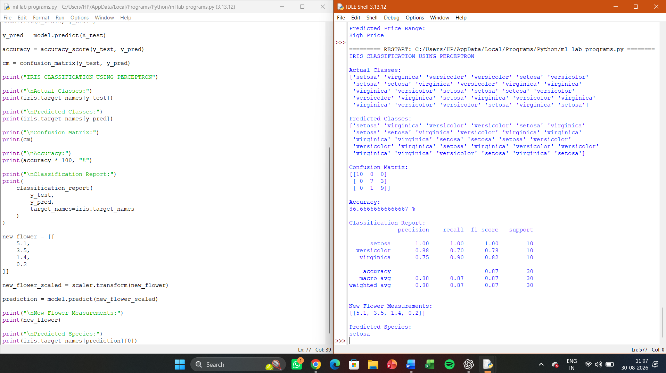

EXPERIMENT 19:
Implementation of Naive Bayes classification for Bank Loan prediction

Aim
To implement Naive Bayes classification for Bank Loan Prediction in Python and predict whether a customer is eligible for a loan based on financial and personal attributes.
Procedure
- Create a bank loan dataset.
- Separate input features and target variable.
- Encode categorical attributes into numerical values.
- Split the dataset into training and testing sets.
- Train a Gaussian Naive Bayes classifier.
- Predict loan approval for test samples.
- Calculate accuracy and display the confusion matrix.
- Predict the loan approval status for a new customer.
Coding
import pandas as pd
from sklearn.model_selection import train_test_split
from sklearn.preprocessing import LabelEncoder
from sklearn.naive_bayes import GaussianNB
from sklearn.metrics import accuracy_score, confusion_matrix, classification_report

data = pd.DataFrame({
"Age": [25, 30, 35, 40, 45, 50, 28, 32, 38, 42,
27, 36, 48, 52, 29, 34, 41, 46, 31, 39],

"Income": [25000, 30000, 45000, 60000, 75000, 90000,
28000, 40000, 55000, 65000, 22000, 48000,
85000, 95000, 32000, 42000, 58000, 70000,
35000, 52000],

"LoanAmount": [10000, 15000, 20000, 25000, 30000, 35000,
12000, 18000, 22000, 28000, 10000, 20000,
30000, 40000, 15000, 22000, 25000, 32000,
14000, 23000],

"CreditScore": [580, 600, 650, 700, 750, 780,
590, 640, 690, 720, 570, 660,
760, 800, 610, 670, 710, 740,
620, 680],

"Employment": [
"No", "Yes", "Yes", "Yes", "Yes", "Yes",
"No", "Yes", "Yes", "Yes", "No", "Yes",
"Yes", "Yes", "Yes", "Yes", "Yes", "Yes",
"No", "Yes"
],

"Loan_Approved": [
"No", "No", "Yes", "Yes", "Yes", "Yes",
"No", "Yes", "Yes", "Yes", "No", "Yes",
"Yes", "Yes", "No", "Yes", "Yes", "Yes",
"No", "Yes"
]
})

encoder = LabelEncoder()

data["Employment"] = encoder.fit_transform(data["Employment"])
data["Loan_Approved"] = encoder.fit_transform(data["Loan_Approved"])

X = data.drop("Loan_Approved", axis=1)
y = data["Loan_Approved"]

X_train, X_test, y_train, y_test = train_test_split(
X,
y,
test_size=0.25,
random_state=42,
stratify=y
)

model = GaussianNB()

model.fit(X_train, y_train)

y_pred = model.predict(X_test)

accuracy = accuracy_score(y_test, y_pred)

cm = confusion_matrix(y_test, y_pred)

print("BANK LOAN PREDICTION USING NAIVE BAYES")

print("\nActual Values:")
print(y_test.values)

print("\nPredicted Values:")
print(y_pred)

print("\nConfusion Matrix:")
print(cm)

print("\nAccuracy:")
print(accuracy * 100, "%")

print("\nClassification Report:")
print(
classification_report(
y_test,
y_pred,
target_names=["Not Approved", "Approved"],
zero_division=0
)
)

new_customer = pd.DataFrame({
"Age": [35],
"Income": [50000],
"LoanAmount": [20000],
"CreditScore": [680],
"Employment": [encoder.transform(["Yes"])[0]]
})

prediction = model.predict(new_customer)

print("\nNew Customer Details:")
print(new_customer)

if prediction[0] == 1:
print("\nLoan Prediction: Approved")
else:
print("\nLoan Prediction: Not Approved")
Result
The Naive Bayes classification algorithm was successfully implemented for Bank Loan Prediction. The model predicts whether a loan is Approved or Not Approved and evaluates its performance using accuracy, confusion matrix, and classification report.

OUTPUT:
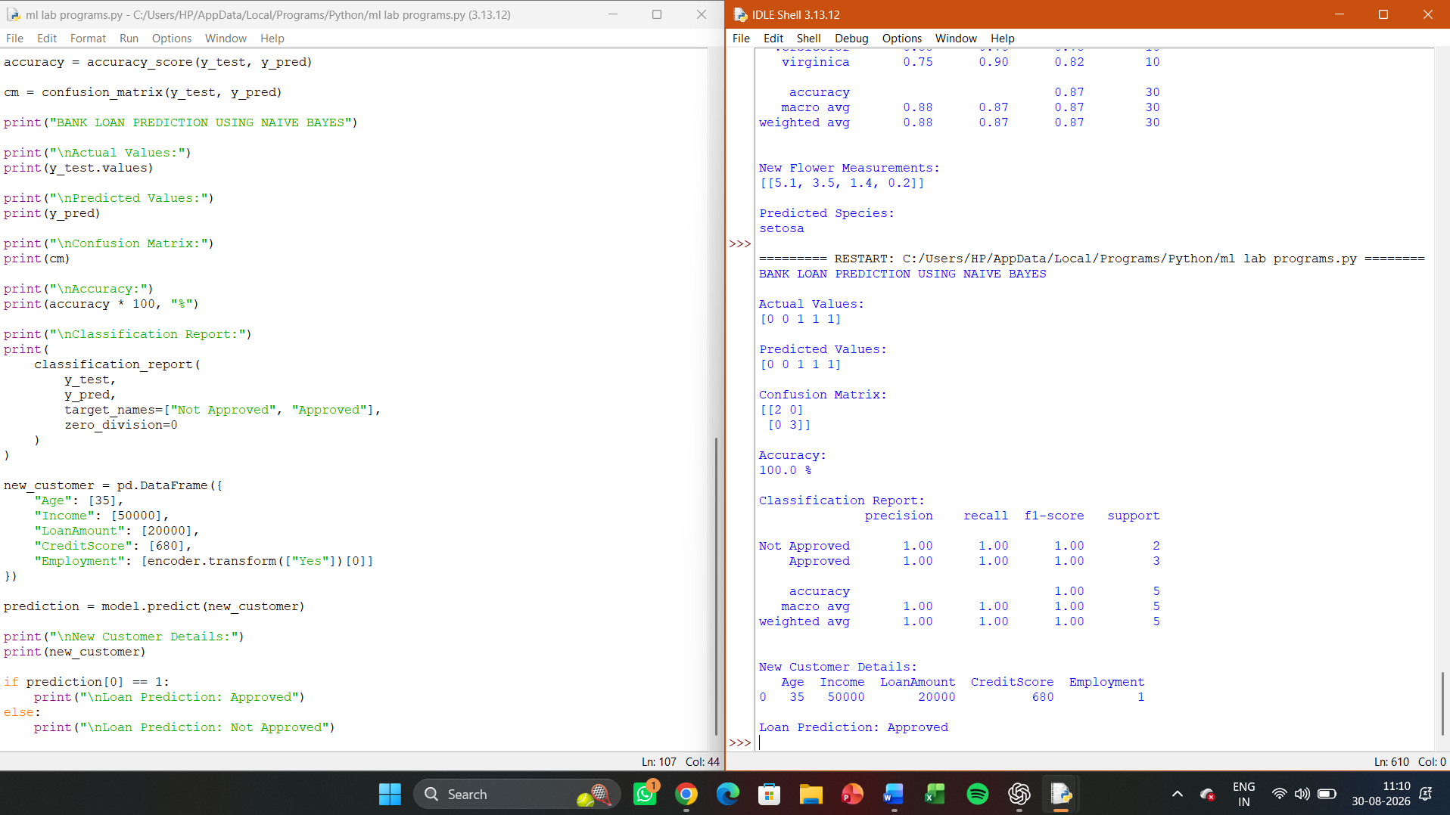

EXPERIMENY 20:
Implement Future Sales Prediction using a suitable machine learning algorithm

Aim
To implement Future Sales Prediction using a suitable machine learning algorithm in Python and predict future sales based on historical sales data.
Procedure
- Create a historical sales dataset.
- Prepare the input and target variables.
- Split the data into training and testing sets.
- Train a Linear Regression model.
- Predict sales for the test data.
- Evaluate the model using Mean Squared Error (MSE) and R² Score.
- Predict future sales for a new time period.
Coding
import numpy as np
import pandas as pd
from sklearn.linear_model import LinearRegression
from sklearn.metrics import mean_squared_error, r2_score

data = pd.DataFrame({
"Month": [1, 2, 3, 4, 5, 6, 7, 8, 9, 10, 11, 12],
"Sales": [120, 135, 150, 160, 175, 190, 205, 220, 235, 250, 270, 290]
})

X = data[["Month"]]
y = data["Sales"]

X_train = X.iloc[:9]
y_train = y.iloc[:9]

X_test = X.iloc[9:]
y_test = y.iloc[9:]

model = LinearRegression()

model.fit(X_train, y_train)

y_pred = model.predict(X_test)

mse = mean_squared_error(y_test, y_pred)
r2 = r2_score(y_test, y_pred)

print("FUTURE SALES PREDICTION")

print("\nActual Sales:")
print(y_test.values)

print("\nPredicted Sales:")
print(y_pred.round(2))

print("\nMean Squared Error:")
print(round(mse, 4))

print("\nR2 Score:")
print(round(r2, 4))

future_months = np.array([[13], [14], [15]])

future_sales = model.predict(future_months)

print("\nFuture Sales Prediction:")

for month, sales in zip(future_months.flatten(), future_sales):
print("Month", month, ":", round(sales, 2))
Result
The Future Sales Prediction model was successfully implemented using Linear Regression. The model learned the trend from historical sales data and predicted sales for future months. The performance was evaluated using MSE and R² Score.
OUTPUT:
